//test_1 ( 3rd march)

//Q1

#include<stdio.h>

void main(){

int hr,min,sec,total=0;

printf("Enter hr :");

scanf("%d",&hr);

printf("Enter min :");

scanf("%d",&hr);

printf("Enter sec:");

scanf("%d",&hr);

total=(hr*3600)+(min*60)+sec;

printf("Total sec: %d ",total);

}

Output

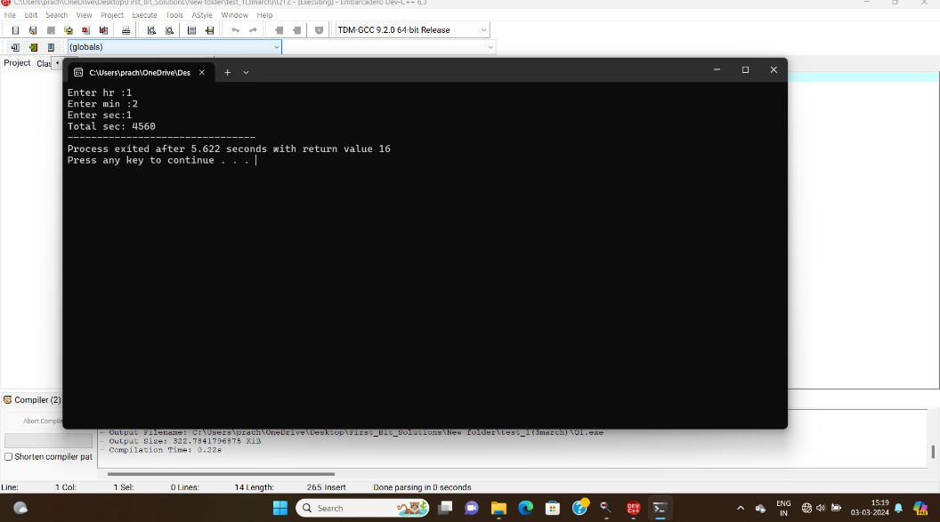

Q2

//Q2

#include<stdio.h>

void main(){

int year=1900;

if(year%100!=0){

if(year%4==0){

printf("this is leap year");

}

else{

printf("This is not leap year");

}

}

else{

if(year%400==0){

printf("this is leap year");

}else{

printf("This is not leap year");

}

}

}

Output

